Dear Sellers of 123 Apple Street,

We cannot express to you how much we love your home. It is easy to see the love and care you put into making this house so special, so warm, and so inviting.

We see this as our forever home. Right now, we are living in a small home in Santa Margarita. As we hope to grow our family in the coming years, we have been on the hunt for a house that gives us space to add an additional babe (or two).

We have a 20-month-old son – Jimmy. He is a wild, fun, curious boy and we can see him spending so much time in this fantastic backyard. Family barbecues, game nights, birthday parties ... we can picture having these special moments here.

Inside this house, we love the layout. It is so bright and inviting! Our cats Bubba and Mr. Cat will love basking in all the natural light. We can see our Christmas mornings by that gorgeous fireplace (swoon!), cooking meals in the beautifully designed kitchen (Jane enjoys cooking), and each bedroom is ready to be a cozy retreat for each member of our family (present and future).

The loft upstairs will be perfect as an art studio (John is an artist and wine steward at Tooth and Nail winery in Paso). It will also serve as a great office space (Jane works from home and has been looking for a space like this to work).

We hope that in the midst of this uncertain time that you are staying healthy and safe, and we wish nothing but the best for your next chapter. Thanks for considering us as the new owners of this warm, beautiful home.

With sincere thanks,
The Smiths
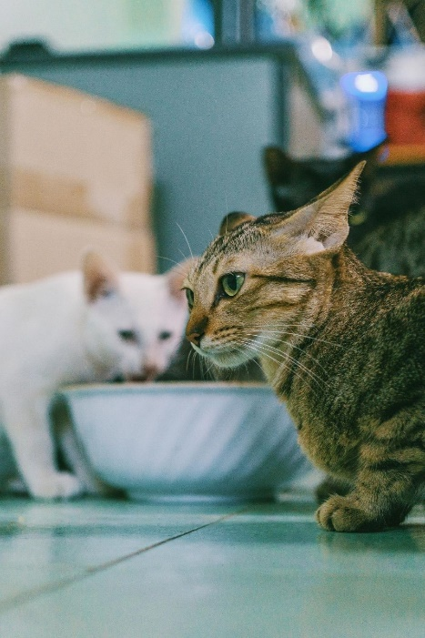
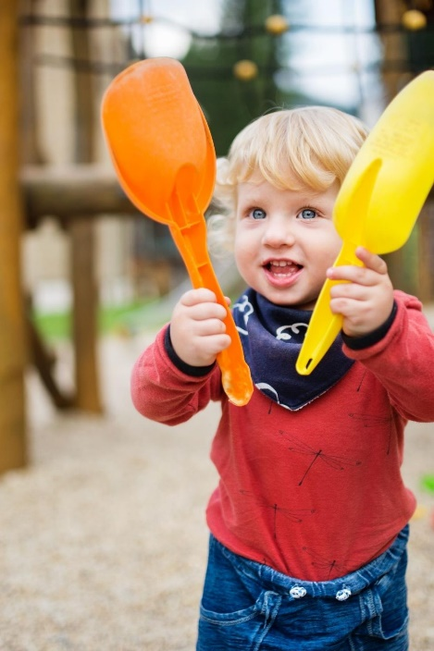
(Jane, John, and Jimmy)

